**Install vscode**

<https://code.visualstudio.com/> -> Download and install the vscode

**Install Django And Python**

1. <https://www.python.org/downloads/> -> Download the latest version and select the install now option.

2. Open the command prompt and type in **py --version** and it should show the version installed

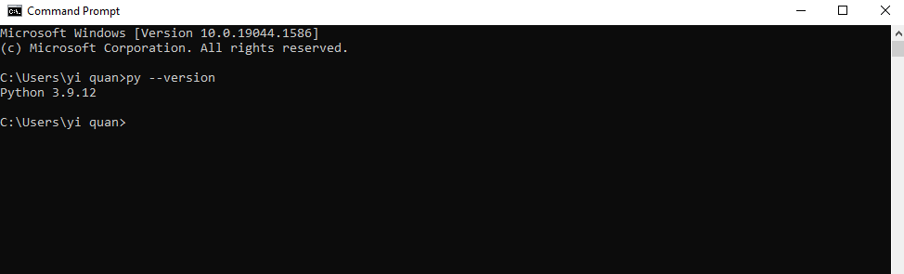

3. Create an environment by running this command in the command prompt, **py -m venv env_name** change the env_name to the name you want like test_env etc..

4. Once the environment is created, change to that env by typing **env_name\Scripts\activate.bat** you will see the (env_name) infront of your current path

5. Once changed to the env, install Django by typing **py -m pip install Django==3.0.3**

**To Run The Code In vscode**

A Django project will have this manage.py file.

You can open the project in vscode by right click and select **Git Bash Here**

Then type in **code .**

At the top right of your terminal if you see bash, you must change it to powershell. The difference between bash and powershell is that powershell is windows “cmd” whereas bash is a linux “cmd”.



If your terminal shows the normal cmd text then skip this part

To change your terminal to windows cmd, press the arrow button beside the **plus (+) button** and select Command Prompt then you should get what is shown in the previous screenshot



To run Django project, you must activate the env that you created previously (you have to do this steps everytime you want to run a Django project in vscode). First change directory to the directory where the env is stored. Mine is stored in C:\Users\yi quan\test_env (you will see Include folder, Lib folder and Scripts folder)

I must change directory to C:\Users\yi quan\test_env\Scripts (to execute the activate.bat in the terminal) in the terminal in vscode

For me, I stored all my projects on D drive rather than C drive so I must change the terminal directory to C drive as my env is stored there. I can just change from D drive to C drive in the terminal by typing **C:** (you can just change to any drive by typing it’s alphabet follow by :)

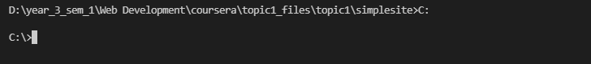

Go to the folder where your env is stored and copy the path to the env\Scripts

In the terminal in vscode type in **cd path_that_you_just_copied**

Once you change directory to that type in **activate.bat** and you should see the env infront of your current path. To exit from the env you can type in **deactivate.bat**



Do not close this terminal and change directory back to your project path and you can run the Django project/command

